William Adoukonou

[Company name]  [Company address]

Dynamic web development assignment 1

Contents

Introduction 1

Task 1 – Creating the Sitemap Plan 2

Website Wireframe 6

Further Wireframe components 8

Mobile Responsiveness 10

Prototype 11

Implementation 13

Home Page 13

About Us Page 14

Popular Dishes 15

Recently Added 16

Contact us page 17

Test Plan 18

Evaluation 18

Security Evaluation 19

Legal Evaluation 20

Conclusion 21

What went well 21

What could have gone better 21

*References* 22

# Introduction

For this assignment, the company Umai Umami have requested for a website to be built for their Japanese Sushi restaurant. It will be a five-page site that has:

Homepage to Introduce the restaurant

Menu that categorizes and presents the sushi and other dish options with enticing descriptions and visuals.

An ‘About Us’ page that share the restaurant's story, team, and any unique aspects of its identity.

A sushi gallery showcasing mouthwatering photos of the dishes and restaurant atmosphere

A contact us page for users to get in touch

The website will also include a design phase with its initial designs with a sitemap, wireframe, and prototype. Once the design and implementation phase have been completed. I will test the website with a set of common tasks to analyze its performance and compliance with cyber security and legal practices. The goal for this site is to create a visually appealing, user-friendly experience which is responsive on a range of devices by using HTML, CSS, and JavaScript.

# Task 1 – Creating the Sitemap Plan

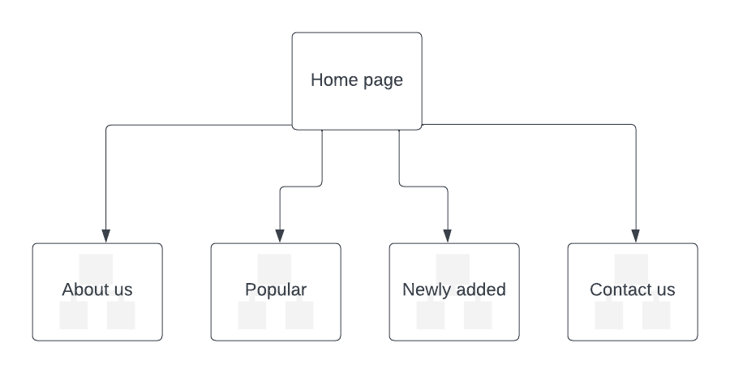The 1st step in creating a website plan is the sitemap. As the name suggests it looks like a map of the entire site except for its heavily scaled down, only showing the hierarchy of each page. Here is a sitemap for the restaurant.

In the sitemap, the homepage is above the rest of them. This shows that it is the main page which can be used to access the others. It is also the first page the user will be sent to when going on the website. To further add to the sitemap, here is a brief layout for each page:

**Home Page**

The homepage consists of the main image, a small description of the restaurant, and a call-to-action button which allows users to order directly from the 1st page. This is useful as it is the main use of the website so having it accessible upon the page loading will increase efficiency.

**About Us**

Every reliable website, regardless of the industry, needs a good about us page. It gives newcomers further insight into your business, the one included in this website will give a few details about the origin of the food and the businesses.

**Popular Dishes**

One fantastic way for users to stay engaged with the website would be to add a “popular dishes” page to the site. This gives browsers an idea of what you are selling while adding a layer of authenticity as users can see your products.

**Newly added**

To add to the “popular dishes,” I have also created a “newly added” section. This is useful for the same reasons as the previous page but makes the site seem more relevant as it has been updated recently. This also helps with how your page ranks on search engines

**Contact us**

This is essential for all companies that have a website. It would be a waste of internet traffic if customers were browsing the webpage but could not contact the actual company. This page will also include 3 CTA buttons which direct the user to the various social media accounts connected to the business. This is important when trying to maximize the target audience of the page. Younger people will be more familiar with contacting the restaurant via social media accounts whereas older people will opt for a phone call or email.

# Website Wireframe

A website wireframe is simply a brief sketch that shows you an idea of the overall structure pages will take, and how users will be able to navigate the site smoothly. For Umai Umami, I will be creating a wireframe for the Homepage. Wireframes follow a basic set of rules:

boxes with diagonal lines through them to represent images

horizontal lines to represent paragraphs of text

and a circle with an L in it to represent your logo.

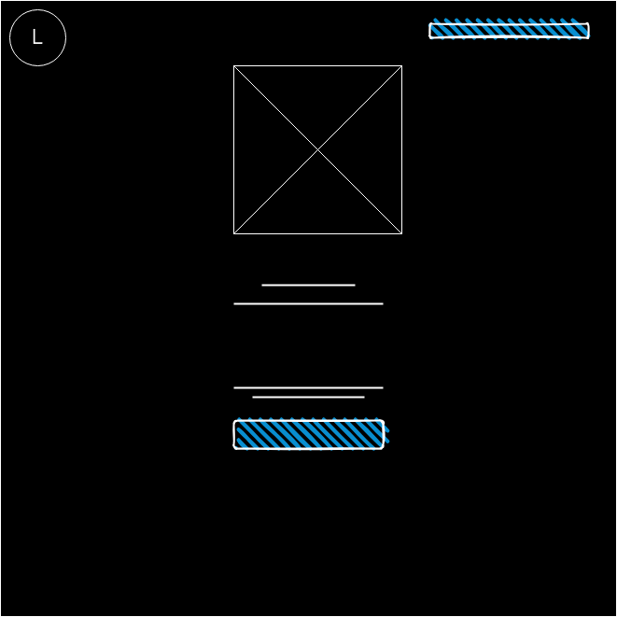

Here is an example of what the homepage will look like in wireframe. The problem with this is that it is “too brief.” This is where designers usually add markup. Markup is notes added to the side of the wireframe so that anyone can easily understand what is going on. Here is what it will look like with markup added.

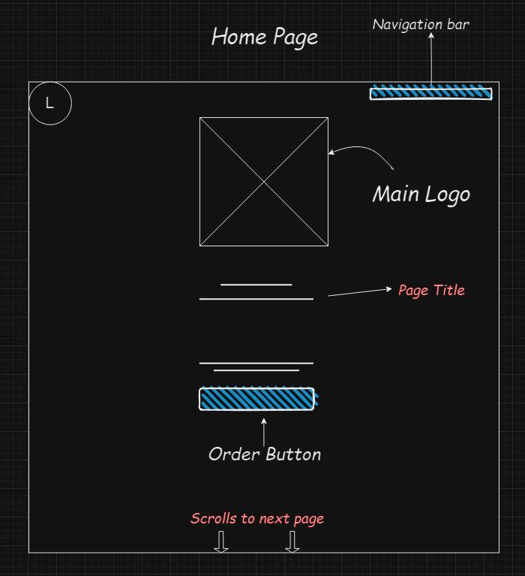

Now the wireframe is much easier to comprehend. It shows which text is the main title, how the next page follows from the main and which boxes are meant for navigation and ordering.

## Further Wireframe components

to make the design of the wireframe easier, I have added the page footer. Since these elements will be repeated throughout the entire website, they can be copied and pasted to the end of each page for ease. Here is an example.

**Contact Page**

The footer has also been added to the contact page. Alongside this, there are links that re-direct the user to the reservation page, store location as well as opening times. For the average visitor, these are the most important links.

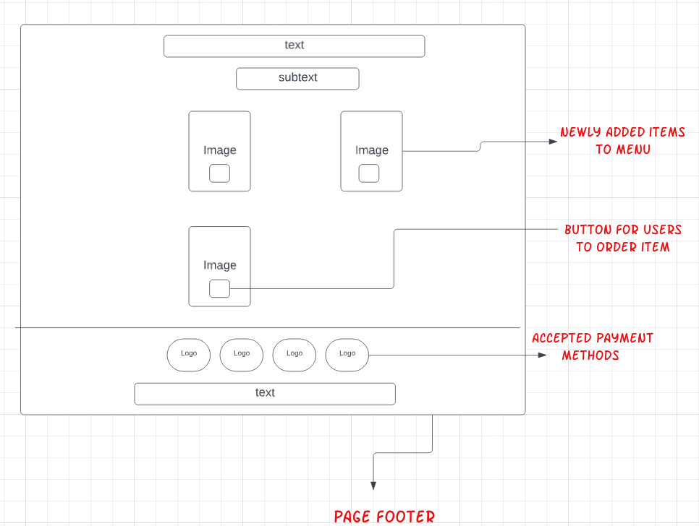**Features Page**

To keep in line with standard web development practices, the footer page has been added to the features page. On top of this the “standard” button of “order now” has been added to make it easier for customers to purchase the food they see on screen

## Mobile Responsiveness

Statistics reveal that 89% of diners leverage the power of their mobile devices to research restaurants before they go out to eat *(restaurant-website-builder, 2024)*. With such a massive portion of your target audience relying on mobile browsing, a website that is not mobile-friendly vanishes for nine out of ten potential customers. Therefore, it is important for the restaurant’s site to work effectively on a smaller device. This is an example of what the website would look like on a mobile.

To make the viewing experience easier for mobile users, text and the products on the image page scroll as the user moves down the website. Mobile users will be used to the scrolling down gesture, making it seamless to read the menu and the longer pieces of text. The logos for the restaurants social media will also stay at the footer of the page.

# Prototype

Using Figma, I have created a small prototype on how the website should look following standard industry practices. The grid lines are an example of where elements should be placed when designing a website.

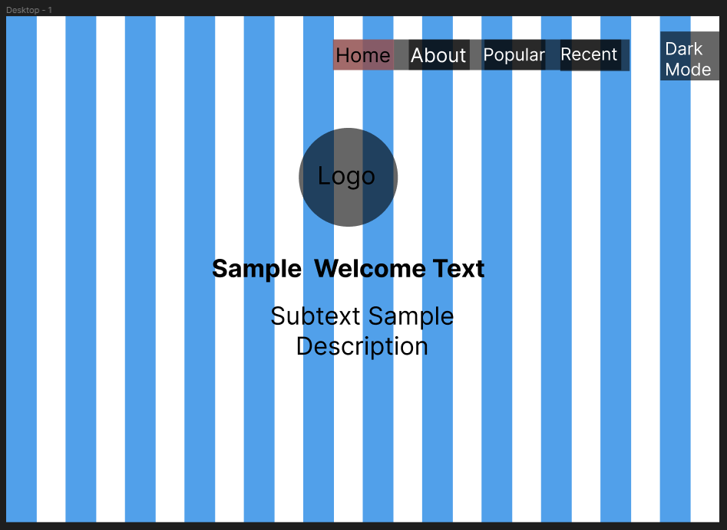As shown in the image, all the elements such as the navigation bar and sample text all fit in line with the grid. This is important as it shows everything on the site is uniform. Along with this I have also added an accessibility feature called Dark Mode. Enabling this will change the colors on the website to a darker pallet, easing strain on user’s eyes.

The prototype has now been transformed into the real design for the website. Using Figma, I have imported the logo, the fonts (Poppins and Lora fonts) and even included the call-to-action button that will also go on the live site. For prototype purposes, the CTA button does not currently work. The logo next to the navigation bar is for a Dark Mode feature. To enhance any user’s experience, I added a dark mode which switches the page contrast to a pallet that is easier on the eyes. This contrast is consistent across the entire website and works on the mobile layout.

# Implementation

## Home Page

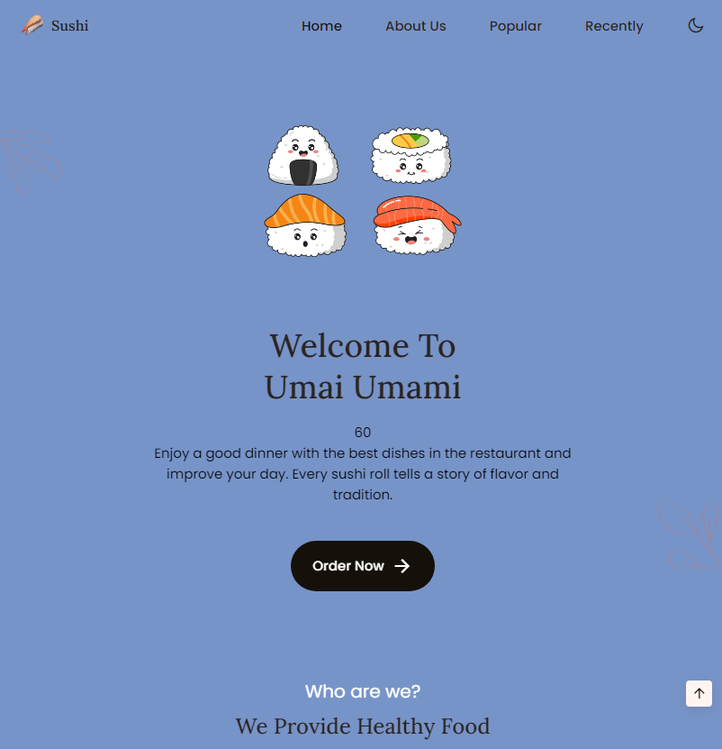

## About Us Page

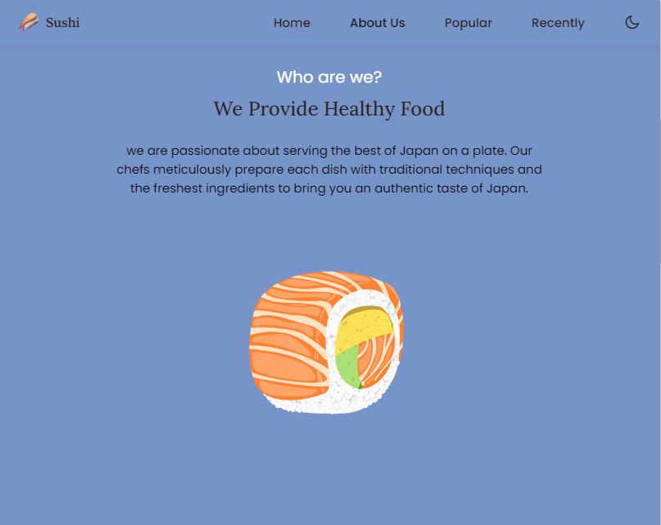

## Popular Dishes

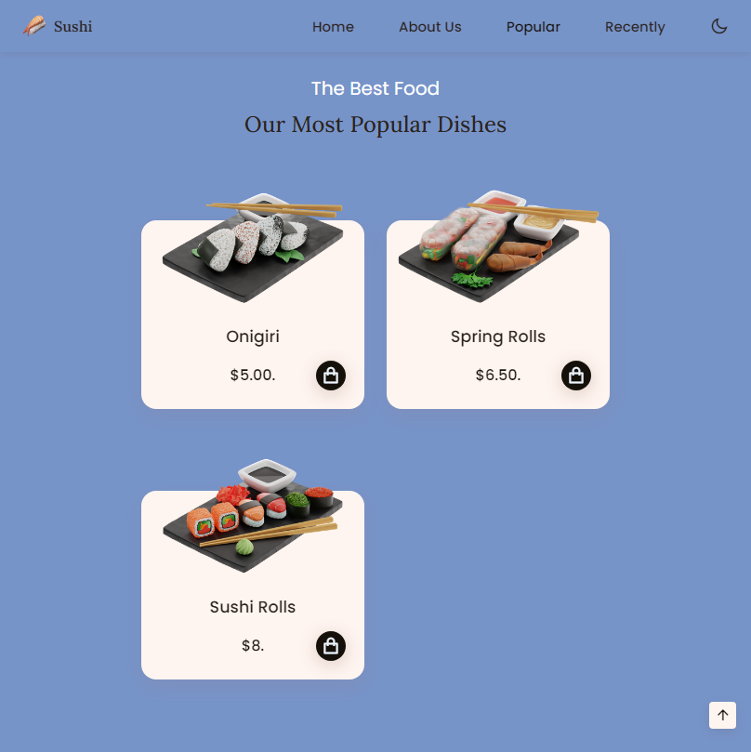

## Recently Added

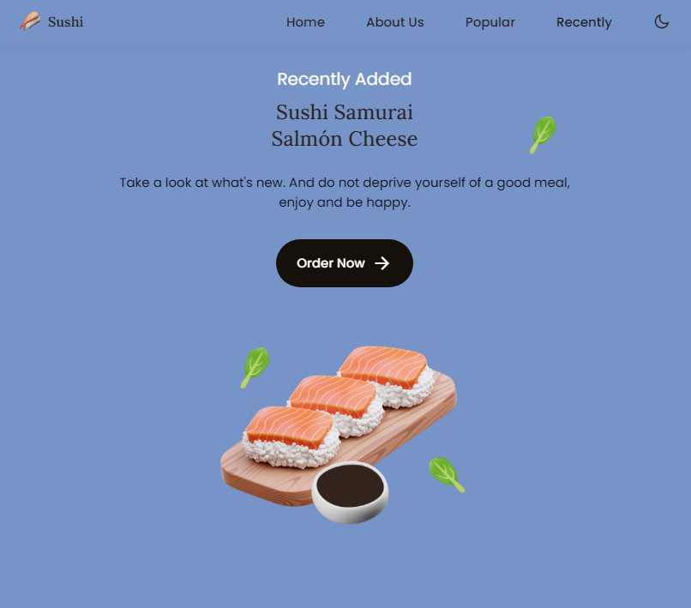

## Contact us page

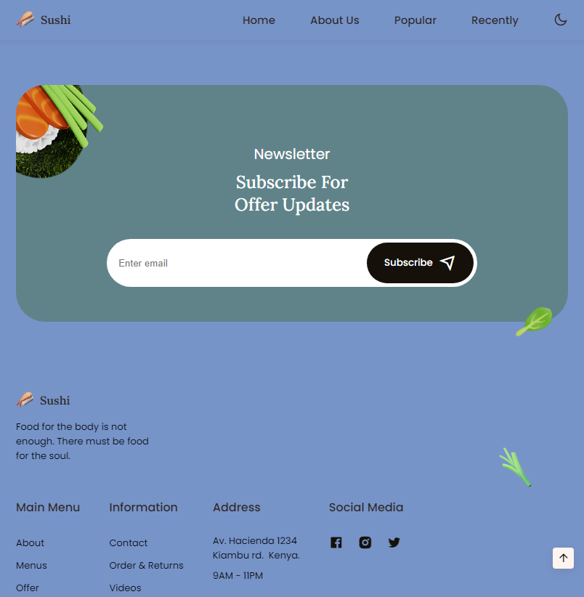

# Test Plan

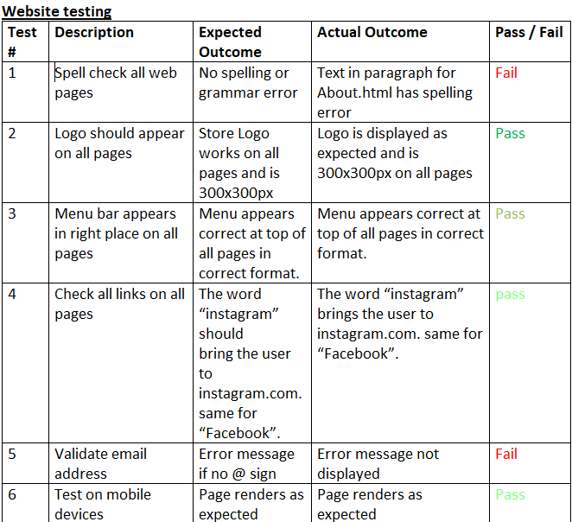

# Evaluation

Although the changes made for the optimized website seem minimal, they were impactful to the design and user perception of the pages. The main improvement that was implemented to the home, about and socials page was the addition of the dark mode. Adding simple quality of life features helped add focus to the text. This directs the user to where to look while being easy on the eyes. This follows one of Schneiderman’s rules of interface design as it reduces the users short term memory load. They do not have to process much info as the website directs them to everything.

On top of this, the images related to the restaurant helped remove the unnecessary whitespaces. White spacing can give clarity to text on sites as well as keep everything neat and tidy. However, having an excessive amount of blank space can give people the impression that your site is lacking information. Adding the images combats this because they relate to the page and act as a universal language to people who may not fully understand the information.

There are 8 golden rules of interface design. These are:

Strive for consistency

Enable Shortcuts based on frequency

Offering informative Feedback

Designing dialog to yield closure

Making Error handling simple

Make it easy to undo errors

Support internal locus of control

Reduce short term memory load

## Security Evaluation

Security is a big part of all websites. Since it is an e-commerce store, it would handle the private information of their customers (addresses, bank details etc.). A website like Amazon has the SSL or “secure socket layer” Certificate. This is a padlock icon next to the search bar that acts like a seal of approval from the search engine. The fact that amazon has this has a positive impact on their organization. People will feel re-assured when purchasing products. Having an SSL lock is also a method of SEO. Websites that do not have the certificate will rank lower in search engines compared to those who do. When the restaurant site is hosted, it is crucial to obtain an SSL certificate.

*Figure 1, Amazon SSL Certificate*

Another way a website can be vulnerable is through SQL or Structured Query Language attacks. They work by the user being able to implement/inject malicious code into a poorly secured database. It would then return whichever data the hacker wants. The several types of SQL attacks are:

Blind This is when the hacker injects SQL code that watches the timing or behaviour of the application's responses to gain the info.

Error Based if an error occurs on the website, then the user is presented with an error code. hackers can use this to inject code that “forces these error codes which leak information about how the website is structured.” *(avast, 2023)*

In-band type of attack is the most used. The code that the hacker injects directly returns the wanted information.

## Legal Evaluation

On the internet, there are certain laws that all websites must comply with regardless of their profession. This is extra important for any sites that obtain data from users, whether that be in the form of contact details (phone number, name, email) or personal info (address, payment information, etc.) these all fall under the data protection act.

The Data Protection Act was updated in 2018 and is now under the GDPR (General Data Protection Regulation). They added more modules to the primary 8. This was to try and avoid loopholes that companies would try and abuse to obtain user data unlawfully. Here are a few.

Transparency - Companies must "be more specific on what data they obtained from the user." *(bath.ac.uk, 2023)*. The user must be aware of what individual pieces of information the company is currently storing. They must also be honest about what exactly they're using the data for. That means if the restaurant wants to use a customer’s details for a mailing list as well as enter it for a survey, they must disclose this too.

Right to be forgotten - The user now has the right to get the company to forget any previously obtained data. "The company must comply and remove the data." If any customer decides they no longer want the restaurant to have their name and phone number, they must remove it *(cornerstonebarristers.com, 2018).*

Children - The same laws in place to protect adults also apply to children. Users under 16 have the same data protection rights that all companies must adhere to. This may not apply directly to this situation however it is still a law.

# Conclusion

## What went well

Overall, the project went successfully. The website is a good reflection of the client’s vision. The overall target audience of younger, online shoppers was kept in mind during the website creation process, and it shows through the theme, matching font and straight to the point images. The example model of the website has also been portrayed through the website. The form page and product page allow the user to do interact with the site rather than just browse images of sushi. Furthermore, the website was crafted in a way where the errors could be easily fixed, they were simple mistakes such as spelling errors that could be easily corrected.

## What could have gone better

The 1st place to look for the solution to this is the test plan. It would have been much better for the site’s overall performance if the site’s layout on larger, desktop devices could have been fixed. This would then allow Umai Umami to appeal to a much wider audience. Research from statista.com shows that 56.89% of all global internet traffic is via mobile, *(statista.com, 2022)*. This is more than half of all internet activity which is just too much to miss.

The reason the site responsiveness could not be fixed was due to time constraints. If I were to do a similar project in the future, I would ensure that each step has a set deadline. This would give me better clarity on my progress and benefit the client, as they could monitor the site's progress if they also had a deadline.

*End of assignment*

# *References*

*GOV.UK. 2023. Data protection: The Data Protection Act - GOV.UK . [ONLINE] Available at: https://www.gov.uk/data-protection#:~:text=Under%20the%20Data%20Protection%20Act,access%20personal%20data. [Accessed 01 March 2023].*

*squareeye. 2023. What Changes for the UK Data Protection Legislation? GDPR and Data Protection Act 2018 | Cornerstone Barristers. [ONLINE] Available at: https://cornerstonebarristers.com/what-changes-uk-data-protection-legislation-gdpr-data-protection-act-2018/. [Accessed 01 March 2023].*

*Amazon (2023). Amazon.co.uk: Low Prices in Electronics, Books, Sports Equipment & more. [online] Amazon.co.uk. Available at:* [*https://www.amazon.co.uk*](https://www.amazon.co.uk)*.*

*Statista (2023). Statista - the Statistics Portal for Market Data, Market Research and Market Studies. [online] Statista.com. Available at: https://www.statista.com.*